**9 SCIENCE 2015**

### BIOLOGY TEST ONE

Name: ____________________ Teacher: ___________________ Mark: /56

**Percentage: %**

**SECTION A: MULTIPLE CHOICE (17 marks)**

**Please answer on the multiple choice answer grid below.**

1. A B C D 10. A B C D

2. A B C D 11. A B C D

3. A B C D 12. A B C D

4. A B C D 13. A B C D

5. A B C D 14. A B C D

6. A B C D 15. A B C D

7. A B C D 16. A B C D

8. A B C D 17. A B C D

9. A B C D

Answer questions 1 to 4 based on the diagram below.

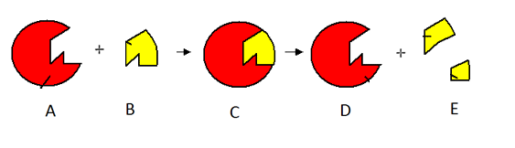

**1.** ‘A’ refers to:

(a) Enzyme molecule.

(b) Reactant molecule.

(c) Catalyst.

(d) Reacting molecule.

**2.** ‘E’ refers to:

(a) Catalyst broken into smaller parts.

(b) Enzyme broken into smaller parts.

(c) Reactant molecule broken into smaller parts.

(d) Reacting molecule broken into smaller parts.

**3.** The diagram is known as a:

(a) Catalyst model.

(b) Lock and key model.

(c) Lock and enzyme molecule.

(d) Key lock model.

**4.** Why are mitochondria so important?

(a) They produce the enzymes required for digestion.

(b) They produce proteins.

(c) They are where cellular respiration occurs.

(d) They are the pacemaker of the heart.

**5.** Choose the incorrect statement:

(a) In many people the left hemisphere of the brain is responsible for language and logical thinking.

(b) The left side of the brain controls the right side of the body.

(c) The cerebellum has two hemispheres.

(d) The function of the folds of the brain is to increase surface area.

Answer questions 6 and 7 based on the diagram below.

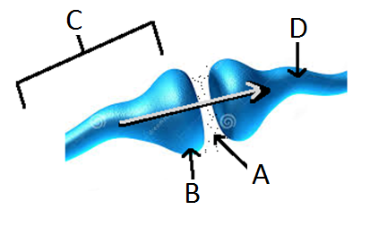

**6.** The diagram shows:

(a) A synapse between two neurones.

(b) A synapsis between two nerves.

(c) A knee joint.

(d) A synopsis between two neurones.

**7.** Label ‘A’ in the diagram refers to:

(a) A vacuum

(b) The neurotransmitter.

(c) The axon.

(d) The neuron.

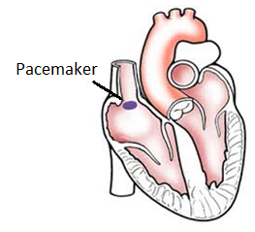

**8.** The function of the SA node (pacemaker) is to:

(a) Open the valves in the heart at the correct time.

(b) Release hormones to contract the atria.

(c) Initiate the heartbeat cycle.

(d) None of the above.

**9.** Choose the correct definition for ‘target cells.’

(a) The cells that hormones act on.

(b) The cells that secrete hormones.

(c) Endocrine glands.

(d) The cells that enzymes act on.

**10.** Which of the following matches the sense with its correct receptor?

|  |  |  |
| --- | --- | --- |
| **Select from** | **Sense** | **Receptor** |
| (a) | Sight | Thermoreceptor |
| (b) | Smell | Photoreceptor |
| (c) | Taste | Chemoreceptor |
| (d) | Hearing | Olphactoreceptor |

**11.** Select the incorrect statement below.

(a) Nerve impulses can only travel in one direction.

(b) Nerve impulses are electrical messages carried by a nerve cell.

(c) The nervous system is made up of hundreds of nerve cells.

(d) Electrical messages are also known as nerve impulses.

**12.** Select the **incorrect** statement below.

(a) The liver breaks down haemoglobin.

(b) The liver breaks down hormones.

(c) The liver breaks down toxic substances.

(d) The liver breaks down glucose.

**13.** Choose the correct definition for ‘ribosomes’.

(a) Organelles that make proteins.

(b) The chemicals between neurones

(c) Organelles that are involved in cellular respiration.

(d) They break down insulin and other hormones.

**14.** During digestion carbohydrates are broken down into:

(a) Glycerol.

(b) Amino acids.

(c) Glucose.

(d) Fatty acids.

**15.** Which of the following has the best description of the process showing in the diagram below?

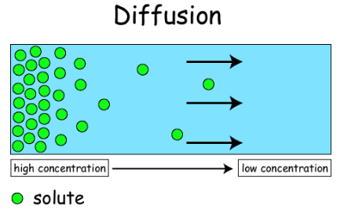

(a) Enzymes cause the spreading out of particles.

(b) Diffusion is the movement of particles from high concentration to low concentration.

(c) Diffusion is the movement of particles from low concentration to high concentration.

(d) Small molecules are more easily absorbed by the digestive system.

**16.** Where on the following diagram would you find photoreceptors?

(a) Label 2.

(b) Label 3.

(c) Label 6.

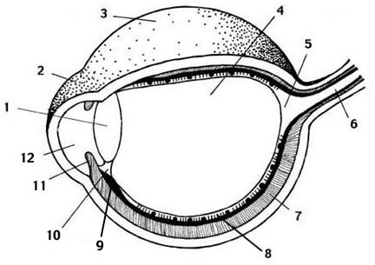 (d) Label 8.

**17.** Select the correct statement about human photoreceptors.

(a) Rods work best in dim light and are responsible for colour vision.

(b) Rods work best in bright light and are responsible for colour vision.

(c) Cones work best in dim light and are responsible for colour vision.

(d) Cones work best in bright light and are responsible for colour vision.

**SECTION B: SHORT ANSWER (39 marks)**

**1a.** Label the diagram below. (3.5 marks)

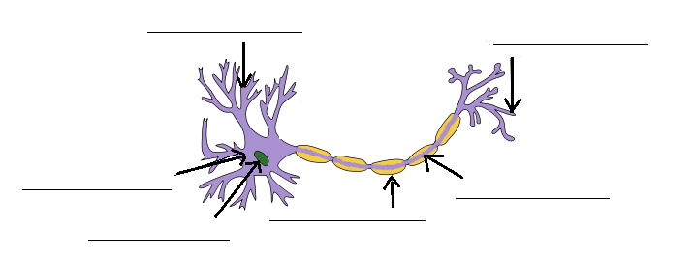

**b.** State the type of neuron shown in the diagram above.__________________________________

**2a.** Label the diagram below. (3.5 marks)

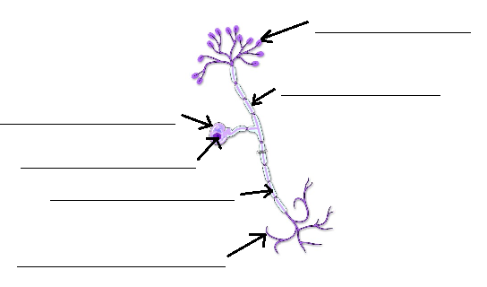

**b.** State the type of neuron shown in the diagram above.__________________________________

**3.** State the main structural difference between motor neurones and sensory neurones. (1 mark)

_____________________________________________________________________________________

_____________________________________________________________________________________

**4.** Explain the process occurring in the diagram below (mention the substances that the secreting cell secretes).(4 marks)

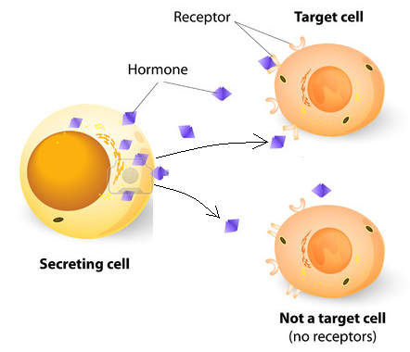

_____________________________________________________________________________________

_____________________________________________________________________________________

_____________________________________________________________________________________

_____________________________________________________________________________________

_____________________________________________________________________________________

_____________________________________________________________________________________

_____________________________________________________________________________________

_____________________________________________________________________________________

_____________________________________________________________________________________

_____________________________________________________________________________________

**5a.** State the name of the process shown in the diagram below. (1 mark)

_____________________________________________________________________________________

**b.** Fill in the table below placing the letters next to their correct label.(3 marks)

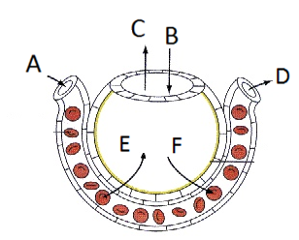

|  |  |
| --- | --- |
| Letter | Label |
|  | Air in |
|  | Oxygenated blood |
|  | Movement of carbon dioxide |
|  | Deoxygenated blood |
|  | Air out |
|  | Movement of oxygen |

**c.** These sentences are describing what is happening in the diagram in question 5.

Fill in the missing words below. You may need to use the same word more than once.

(2 marks)

Oxygen moves from the __________________________ where there is a greater concentration of oxygen to the ___________________________ where there is a lower concentration of oxygen.

Carbon dioxide moves from the __________________________ where there is a greater concentration of carbon dioxide to the ___________________________ where there is a lower concentration of carbon dioxide.

**6.** Fill in the blanks on the diagram below, please use the full names not initials or abbreviations (6 marks)

**The Nervous System**

**_______________________________________**

**_______________________________________**

Made up of the brain and spinal cord.

**__________________________________________**

**___________________________________________**

Carries messages from the CNS to the rest of the body

**___________________________________________________**

**___________________________________________________**

Part of the nervous system that:

____________________________________________________

____________________________________________________

E.g.: touch, smell, taste, hearing, sight.

**_________________________________________**

**__________________________________________**

Controls unconscious activities in your body

**___________________________________________**

**___________________________________________**

Slows down the functions of the body

One function this system has is to:

___________________________________________

___________________________________________

___________________________________________

___________________________________________

**___________________________________________**

**___________________________________________**

Speeds up the functions of the body

One function this system has is to:

___________________________________________

___________________________________________

___________________________________________

___________________________________________

**7.** Label the diagram below. (3 marks)

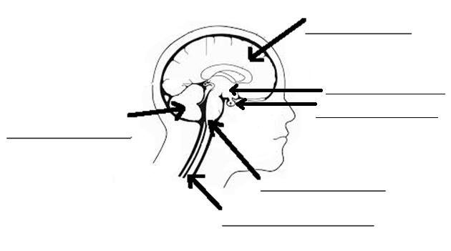

**8.** Fill in the missing words below. (2 marks)

The endocrine system is controlled by the _____________________ gland. This gland responds to _____________________ released by the hypothalamus. The hypothalamus’ role is to monitor the internal environment and maintain ________________________. It is also the link between the endocrine and ________________________ systems.

**9.** Describe the function of the myelin sheath. (2 marks)

_____________________________________________________________________________________

_____________________________________________________________________________________

**10.** Write a definition for ‘effectors’. (2 marks)

_____________________________________________________________________________________

_____________________________________________________________________________________

_____________________________________________________________________________________

**11.** Two students were testing the effectiveness of an enzyme on breaking down proteins into amino acids. When protein is broken down into amino acids it turns clear.

The students had two test tubes in a water bath (container with water). Both of the test tubes had some egg white (protein) in the bottom. One of the test tubes also had an enzyme called protease added to it. The test tubes were placed in a water bath and left there for 20 minutes.

They repeated the experiment three times. Their set up is shown below:

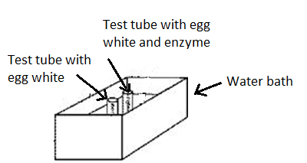

After 20 minutes they obtained the following results:

|  |  |  |
| --- | --- | --- |
| Trial | With enzyme | Without enzyme |
| 1 | Turned Clear | Remained white |
| 2 | Turned Clear | Remained white |
| 3 | Turned Clear | Remained white |

**a.** State the independent variable in this experiment. (1 mark)

_____________________________________________________________________________________

**b.** State the dependent variable in this experiment. (1 mark)

_____________________________________________________________________________________

**c.** List two variables that should be controlled. (2 marks)

_____________________________________________________________________________________

_____________________________________________________________________________________

**d.** Explain what they could conclude from the results they obtained. (2 marks)

_____________________________________________________________________________________

_____________________________________________________________________________________

_____________________________________________________________________________________

_____________________________________________________________________________________